Day 3

Node modules

**Example 1:**

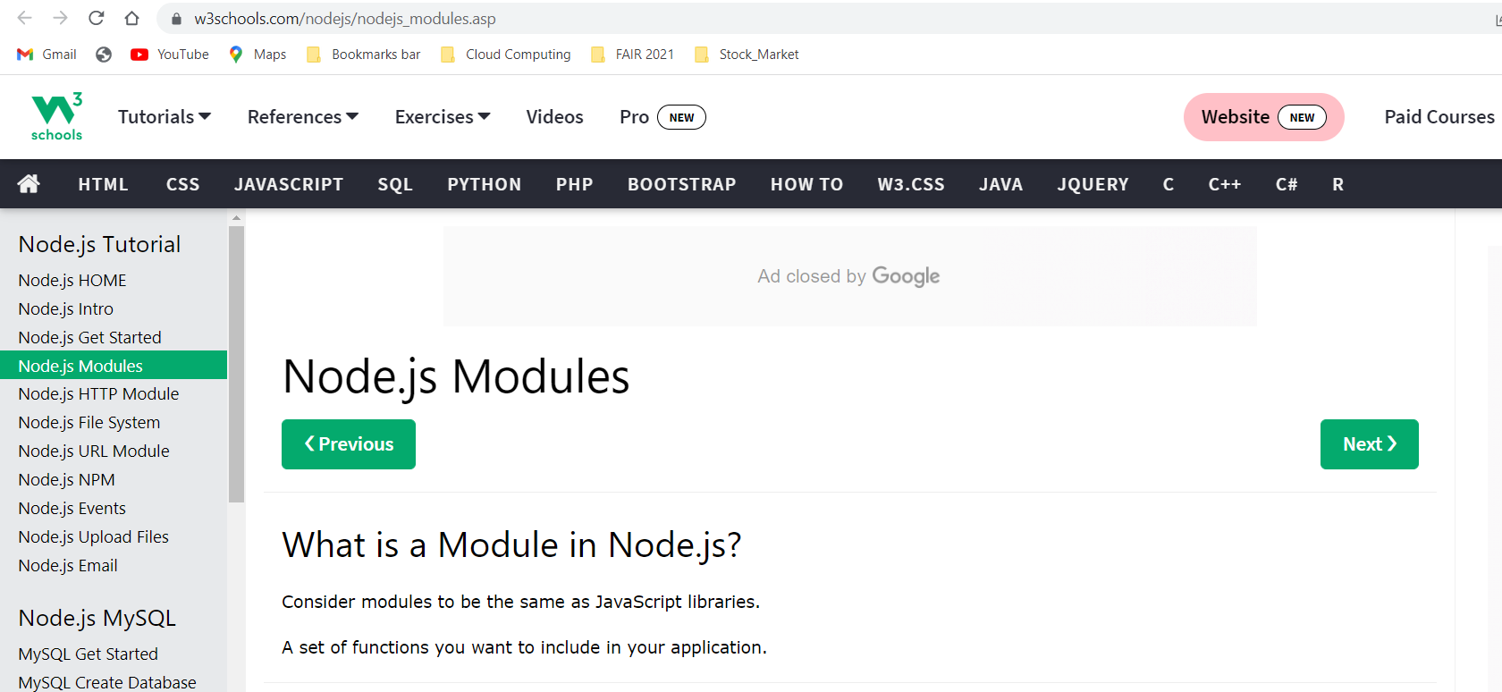

**File:** **myfirstmodule.js**

exports.myDateTime = function () {

return Date();

};

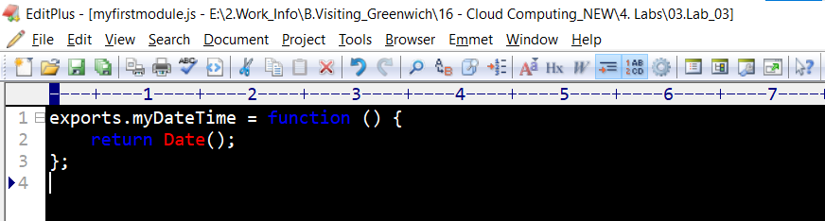

**File:** **demo_module.js**

var http = require('http');

var dt = require('./myfirstmodule');

http.createServer(function (req, res) {

res.writeHead(200, {'Content-Type': 'text/html'});

res.write("The date and time are currently: " + dt.myDateTime());

res.end();

}).listen(8080);

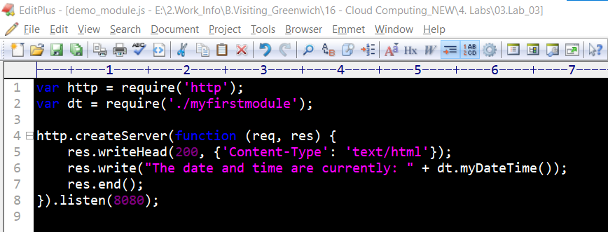



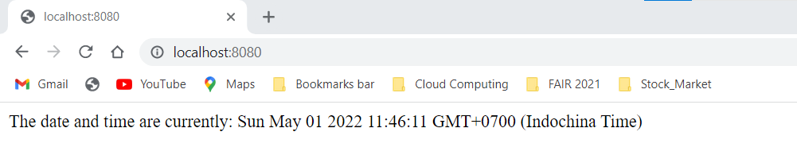

**Example 2:**

**File: mymodule.js**

**const calc = (a,b,p) => {**

**/\***

**if (a || b || p ) {**

**return "Please provide all parameters" ;**

**}**

**\*/**

**switch (p) {**

**case '+' : {**

**return a+b;**

**break ;**

**}**

**case '-' : {**

**return a-b;**

**break ;**

**}**

**case '*' : {**

**return a*b;**

**break ;**

**}**

**case '/' : {**

**return a/b;**

**break ;**

**}**

**default :{ return ;}**

**}**

**}**

**exports.calc=calc; //very important line**

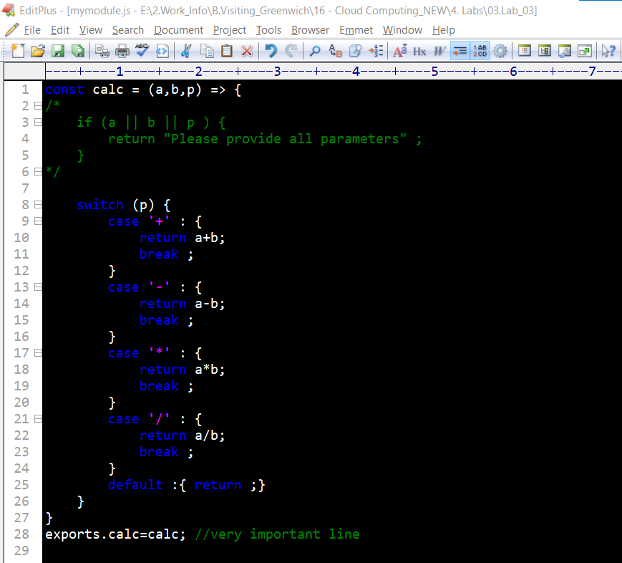

**File: demo_module_calc.js**

**var dt = require ( './mymodule' );**

**console.log(dt.calc(10,20,'+'));**

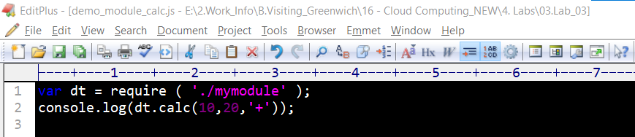



Day 4

Files

**File: demo_copy.js**

**const fs = require ( 'fs' );**

**fs.copyFile( file.txt' , 'copyfile.txt' , (err) => {**

**if (err) {**

**throw err;**

**}**

**console .log( 'File is copied!' );**

**});**

